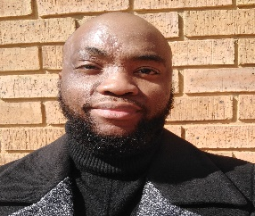
Moabi
Mokoena
IT Technician
I am a professional IT Technician with proven record to learn under pressure and still achieve company goals and reach set milestones. In 2 years I was able to do technical support work and I was counted among the best in my team. I was given a team leader titles.
I have a proven record that shows my abilities and skills as an IT Technician to maintain computer and network systems of an organisation

Ricoh SA- 07/2019 to 04/2020

I Installed and maintained Ricoh printers. Identified printer equipment shortages and place orders. Performed troubleshooting, diagnose and resolve problems (repair or replace parts, debugging), and established network connectivity to the Ricoh devices in conjunction with customers IT representatives.

Field Technician
IT-Varsity- (in-progress)
Systems Development NQF level 5 NQF level 5 - SAQA ID: 48872
ProServ SA- 2019
Technical Support NQF level 4 - SAQA ID: 78964
IIE Rosebank College– 2017
Diploma: Information Technology Management level 6 - SAQA ID: 71636
SAQA ID: 71636

About Me
Work Experience
Education
Contact me
+27-81-282-5918
Moabi.karabo@yahoo.com
1142 Masaka str, Tsakane 1550
I volunteered my time on this start-up company to learn and gain experience. I did Camera Support and Installation with remote viewing, I Pulled network cables from the server room to network points and installing wireless access points. Set up workstations and necessary peripheral devices and checked computer hardware to ensure functionality. I Identified computer and network equipment shortages and place orders.

moabi.mokoena.itvarsitystudent.org/

linkedin.com/in/mk-mokoena
Machava Solutions- 07/2016 to 09/2017

IT Technician

Skills
Computer Technical
Software
Problem Solving
Creativity
Coding / Text editing software
Equipment repairs and installations
Problem-Solving 
Communication
Time management

